Classification of Abalones Data
Goal: Predicting age of abalones
Input variables: Sex, Length, Diameter, Height, Whole weight, Shucked weight, Viscera weight, Shell weight, Rings
- Sex is either Male ("M"), Female ("F") or Infant ("I"), this is not suitable for regression algorithms, so I created a numeric feature: 1:Male, 2: Female, 3:Infant
- There are no missing/null values in dataset. At 2 places height is 0mm , but considering it in mm we can ignore it considering 4000 rows
- Added age column in the dataframe for classification. Age is classified based on the number of rings.
Rings 1-8 -->Age 1, denoting young
Rings 9-10 -->Age 2, denoting middle
Rings 11-29 -->Age 3, denoting old

Exploratory Analysis:
1.
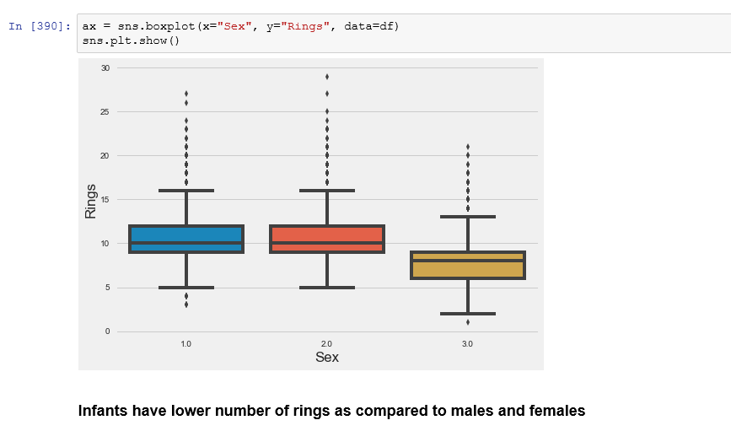
2.
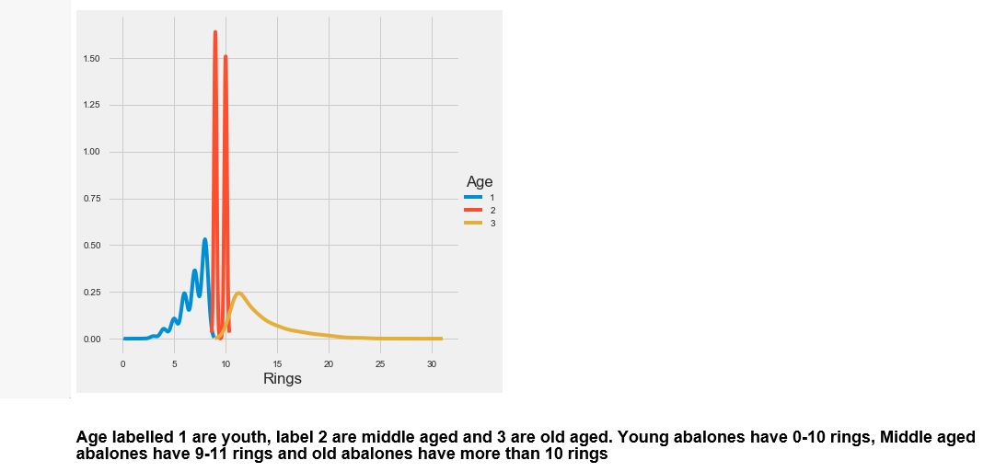

3.
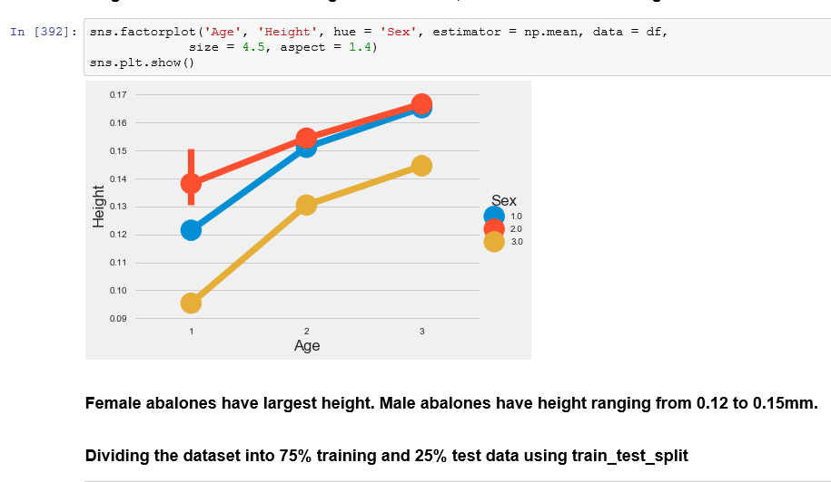

I used 4 classification algorithms and their respective accuracy is as follows:
Models | Accuracy | Root mean square error(RMSE) | Mean Absolute error(MAE)
Neural Network | 64.6889952153 | 0.6777389936698861 | 0.388516746411
Logistic Regression | 65.2631578947 | 0.6903296487356203 | 0.39043062201
Random Forest | 62.5837320574 | 0.7254762501100116 | 0.424880382775
KNN Classifier | 61.8181818182 | 0.7228333405962345 | 0.428708133971
Conclusion: Neural network gives highest accuracy for classification of age data among all the 4 models, depending on rmse value of 0.677 which is lowest.

